EP 108 REPORT PAPER
EXPERIMENT NAME: Measurement of Resistance and Resistivity by the Wheatstone Bridge Method
EXPERIMENT NO: 4
STUDENT NAME SURNAME:
STUDENT NUMBER:
DEPARTMENT&EDUCATION TYPE:

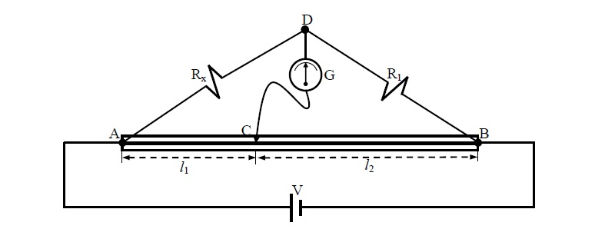

R₁ =10Ω
Length of the wire 100 cm
l₁= 84cm
Calculate unknown resistance R_{x} value. If the unknown resistance value is 50Ω, calculate percentage error.

$R_{x}=R_{1}\frac{l_{1}}{l_{2}}$

